ASSIGNMENT-10

CREATING RDS DATABASE AND CONNECTING IT TO SERVER VIA PORT 5432

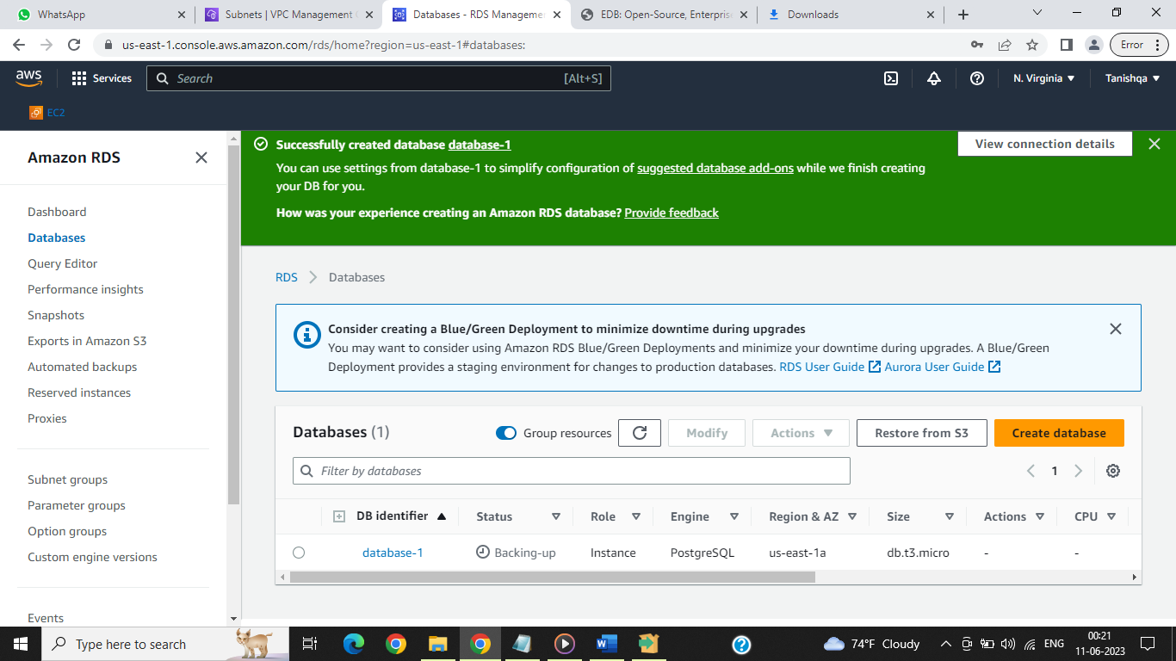

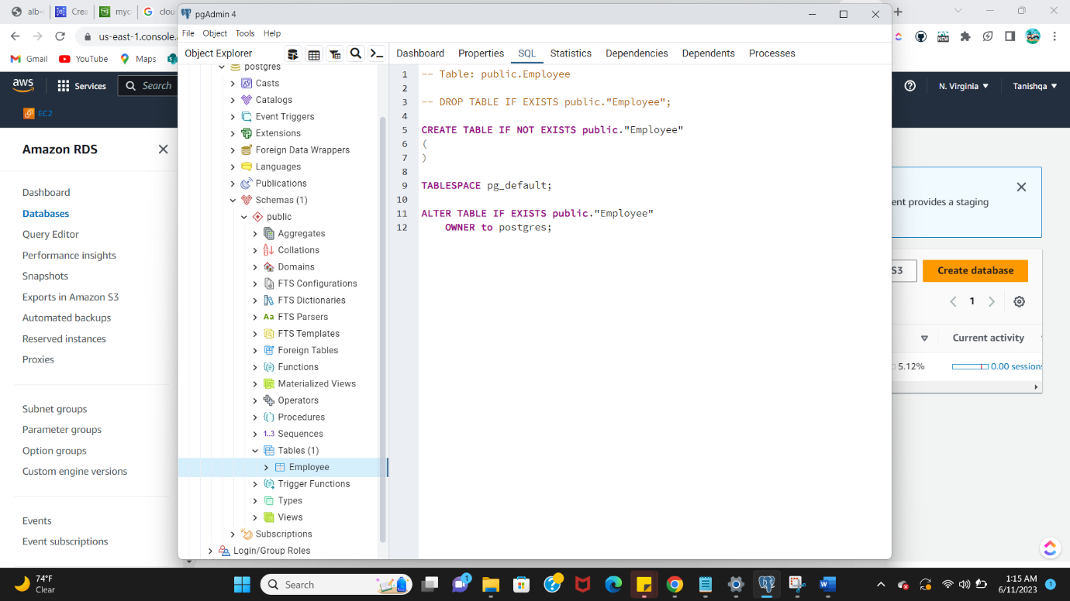

3-TIER ARCHITECTURE:

